**Experiment - 6**

1. Digitizing image intensity amplitude is called

A. Sampling

B. Quantization

C. Framing

D. Both A and B

2. Replication of pixels is called

A. coding redundancy

B. spatial redundancy

C. temporal redundancy

D. both b and c

3. In Huffman coding the size of the codebook is L1, while the longest code word can have as many as L2 bits. What is the relationship between L1 and L2?

A. L1<L2

B. L1>L2

C. L1=L2

D. No relation

4. The transform used in JPEG image compression is

B. Discrete cosine transform

C. Walsh transform

D. Discrete wavelet transform

E. KL transform

5. In an image compression system 16384 bits are used to represent a 128*128 image with 256 gray levels. What is the compression ratio for the system?

A. 4

B. 8

C. 12

D. 16

6. Which one of the following is lossy coding?

A. Huffman coding

B. Run length coding

C. Uniform quantizer

D. Predictive coding without quantizer

7. A 256*256 digital image has 8 distinct intensity levels. What is the minimum number of bits required to code this image in a lossless manner?

A. 196606 bits

B. 186608 bits

C. 196608 bits

D. 176600 bits

Answers: Q1 B), Q2 D), Q3 C), Q4 A), Q5 B), Q6 C), Q7 C)

Assignments

Q1

clc;

clear all;

close all;

F = [0 1 0 0;0 1 2 2;0 1 2 3;1 2 2 3]

J = entropy(F)

F =

0 1 0 0

0 1 2 2

0 1 2 3

1 2 2 3

J =

0.8960

Q2

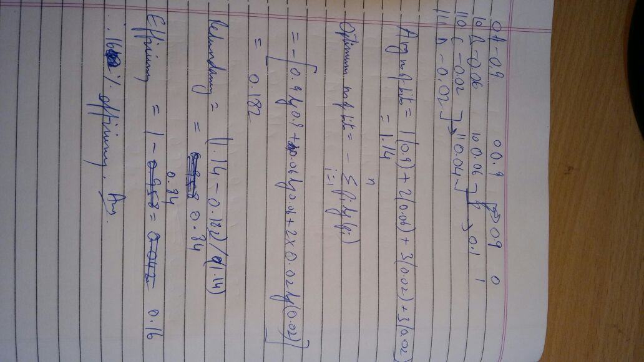

Q3

F = [180 160 94 153 194 163 132 165;

183 153 116 176 187 166 130 169;

179 168 171 182 179 170 131 167;

177 177 179 177 179 165 131 167;

178 178 179 176 182 164 130 171;

179 180 180 179 183 164 130 171;

179 179 180 182 183 170 129 173;

180 179 181 179 181 170 130 169]

G = F-128.*ones(8,8);

I = dct2(G);

Q = [16 11 10 16 24 40 51 61;

12 12 14 19 26 58 60 55;

14 13 16 24 40 57 69 56;

14 17 22 29 51 87 80 62;

18 22 37 56 68 109 103 77;

24 35 55 64 81 104 113 92;

49 64 78 87 103 121 120 101;

72 92 95 98 112 100 103 99];

Qnew = I/Q;

Zigzagcoeff = [20 -31 3 2 -5 44 -18 -5 -4 1 0 -2 -3 1 -32 -65 5 0 -2 1 0 -1 1 -1 0 3 5 139 -64 -9 2 1 0 0 1 0 0 0 0 1 2 -4 4 1 -2 2 0 0 1 0 0 0 -3 1 0 0 0 -1 -1 0 1 2 -1];

K = Q*Qnew;

R = idct2(K)

>> Assignment_2

F =

180 160 94 153 194 163 132 165

183 153 116 176 187 166 130 169

179 168 171 182 179 170 131 167

177 177 179 177 179 165 131 167

178 178 179 176 182 164 130 171

179 180 180 179 183 164 130 171

179 179 180 182 183 170 129 173

180 179 181 179 181 170 130 169

R =

1.0e+03 *

-0.3854 -0.1899 1.8368 -1.3518 -2.1250 4.6541 -3.0113 4.2529

0.4403 0.3589 -1.5109 1.0069 1.6425 -4.2801 2.4430 -3.9483

-0.3975 -0.2800 1.5928 -1.3246 -1.9148 4.5838 -2.7411 4.0961

0.2604 0.1816 -1.0540 0.9056 1.2827 -3.0638 1.8338 -2.7233

-0.1868 -0.1124 0.8336 -0.7292 -1.0303 2.3498 -1.4504 2.0765

0.0898 0.0789 -0.2920 0.2241 0.3335 -0.8970 0.4933 -0.8071

-0.0571 -0.0340 0.2591 -0.2358 -0.3269 0.7390 -0.4586 0.6515

-0.0089 0.0110 0.1113 -0.1150 -0.1537 0.2640 -0.1962 0.2151

Q4

clc;

clear all;

close all;

K = ones(100,35).*128;

L = ones(100,30).*64;

M = ones(100,20).*32;

N = ones(100,10).*16;

O = ones(100,5).*8;

I = [K L M N O];

figure

imshow(uint8(I));



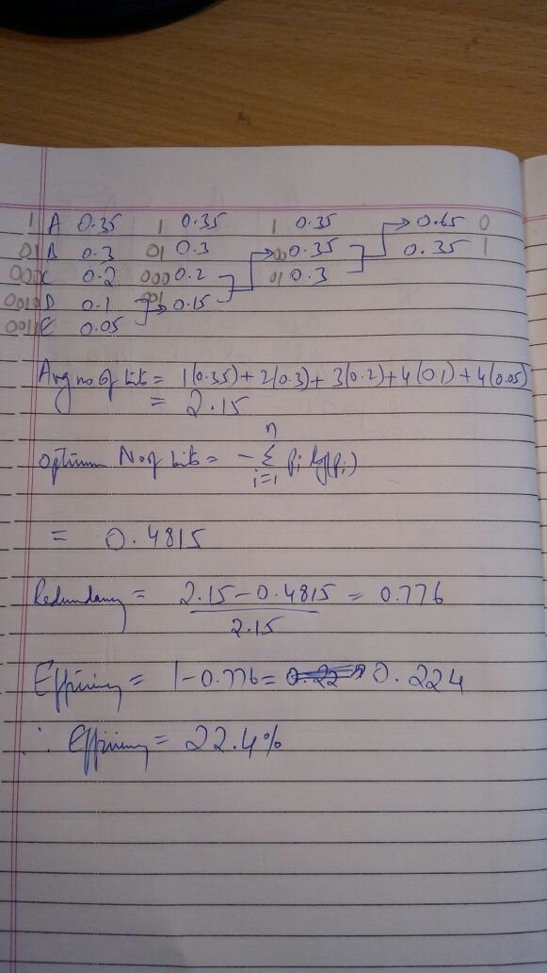

Q5

clc;

clear all;

close all;

RGB = imread('len_top.jpg');

I = rgb2gray(RGB);

J = dct2(I);

J(abs(J) < 10) = 0;

K = idct2(J);

figure

imshowpair(I,K,'montage')

title('Original Grayscale Image (Left) and Processed Image (Right)');

